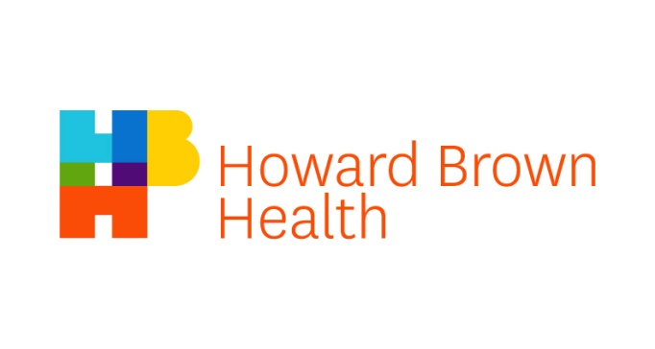

Community Advisory Board Application
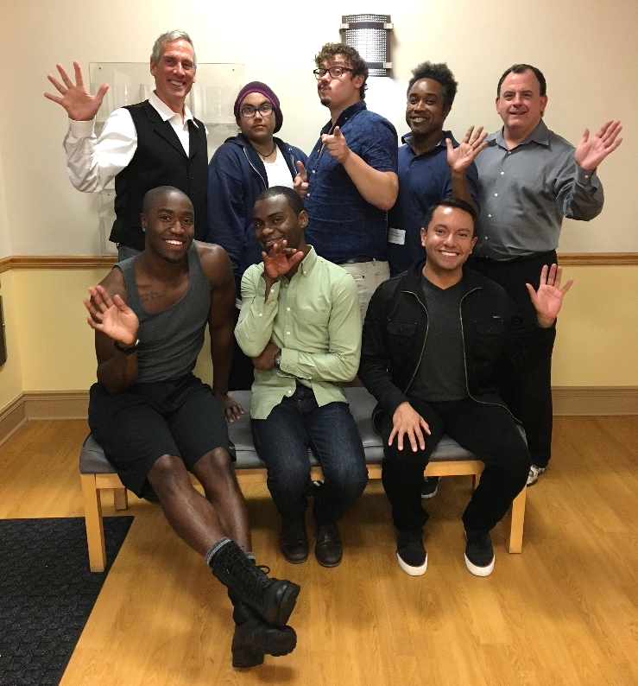
Welcome from 2016-17 CAB Members!

Dear Applicant:

Thank you for your interest in joining the Community Advisory Board (CAB) of Howard Brown Health. The CAB provides community feedback on Howard Brown’s programs and services and helps Howard Brown staff stay connected to the lesbian, gay, bisexual, transgender, queer (LGBTQ) and HIV+ communities in Chicago. Howard Brown is committed to choosing a diverse group of CAB members with different ages, income levels, gender identities, races/ethnicities, sexual orientations, and HIV statuses. Howard Brown is committed to forming a CAB that includes people who have received health care at Howard Brown regularly; this includes medical, therapy, case management or testing services within the last two years.

Purpose
The mission of Howard Brown is to eliminate the disparities in health care experienced by LGBTQ people through research, education and the provision of services that promote health and wellness. The main purposes of the CAB are:
- To advise Howard Brown staff on how the agency can improve its services
- To offer feedback on how well Howard Brown works with members of the community
- To provide a community voice in decisions Howard Brown makes about current and future services

Structure
The Northside CAB will meet for two hours, on the second Wednesday of every month, predominantly at Advocate Illinois Masonic Medical Center (836 W. Wellington Ave.), from 6-8pm.
The Southside CAB, will meet for two hours, on the fourth Wednesday of every month, at Howard Brown Health 63rd located at 641 W. 63rd street, from 5:30 – 7:30pm in the community room.
During the meetings, the CAB will give feedback, react to ideas from staff, and make suggestions that could improve Howard Brown. Possible CAB topics include trans health services, case management services, support groups, youth services, Pride Month activities, HIV/STI testing and outreach, and the Brown Elephant stores. Once members are chosen, the CAB will choose additional topics to discuss.

We hope to create a CAB that is meaningful and rewarding, and offer community members a way to help Howard Brown provide even better care and help shape what Howard Brown will be in the future.

Benefits of Joining the CAB:
- Learning more about the services at Howard Brown
- Having a voice in how Howard Brown improves the healthcare it offers
- Helping Howard Brown staff understand what the community needs

Requirements to be a CAB Member:
- Regularly attend meetings and provide thoughtful feedback
- Read information sent to the CAB to prepare for meetings
- Promote Howard Brown in the community
- Make suggestions about what you think the community need

Applications and Deadlines
To apply to be a member of the CAB, please complete the attached application. Please send your completed application to Howard Brown Staff Liaison, Jessie Savage at JessieS@howardbrown.org. If you have any questions regarding the CAB or the application, please call or email Jessie at (773) 388-1600 ext.7959 or email JessieS@howardbrown.org.

Applications for the CAB are open year-round and will be reviewed at multiple points throughout the year, depending on how many openings there are on the CAB for new members. Applicants may be contacted to arrange an in-person interview with Howard Brown staff and current CAB members.

Thank you again for your interest in the CAB and your choice to have a positive impact on Howard Brown programs and services. We deeply appreciate your commitment to Howard Brown.
All information in this application will be private and confidential. It will only be used for your Community Advisory Board (CAB) Application and will not be part of your other records at Howard Brown Health.

Date _____________________________

________________________________________________________________________
Names You Use or Go by (Last Name, First Name)

_____________________________________________________________________
Gender Pronouns You Use (i.e. she/her, he/him, they/them, xe/xir, name only, etc.)

________________________________________________________________________
Address City State Zip

________________________________________________________________________
Email Address Preferred Phone Alternate Phone

May we mention Howard Brown when calling? □ Yes □ No
Best time to call: □ Day □ Evening

Employer (if applicable): ___________________________________________________________________

Job Title: ________________________________________________________________________

Answering the questions below is optional; you can choose which questions you would like to answer. Your answers will help us choose a CAB that includes all different types of people that receive care at Howard Brown.
Age: ______

Gender (Check all that apply):
□ Man □ Genderqueer
□ Woman □ Gender non-conforming
□ Trans Man/Trans masculine □ Intersex
□ Trans Woman/Trans feminine □ Transgender
□ Other— please specify: _____________________________

Do you identify as a member of the trans and/or gender non-confirming community?
□ Yes □ No

Sexual orientation (check all that apply):
□ Bisexual □ Lesbian
□ Gay □ Queer
□ Heterosexual/Straight □ Questioning
□ Same Gender Loving
□ Asexual
□ Additional sexual orientation—please specify: ____________________

Race/ethnicity (check all that apply):
□ Asian □ Pacific Islander
□ Black/African-American □ Latino/Latina/Hispanic
□ White/Caucasian □ More than one race
□ Native American/Indigenous □ Additional Race/Ethnicity: ___________

Housing Status:
□ I am experiencing homelessness
□ I have somewhere to live but it’s only temporary
□ I have a stable place to live
□ I live in a group home, sober living home or other supported housing
□ Other— please specify: ____________________________________

Highest Level of Education:
□ Some Grade School □ Some High School
□ High School Diploma/GED □ Technical/Trade School
□ Some College □ College Degree
□ Advanced Degree

How many people live with you and share expenses (including you)? _______

Do you have health insurance? □Yes □No

What is your monthly household income? ________________

Are you a veteran? □Yes □No

Do you speak another language(s) fluently besides English? □Yes □ No

If yes, what other language(s) do you speak? ______________________________________

Which describes you? (check all that apply)
□ I am living with HIV □ A close family member of mine is living with HIV
□ A close friend of mine is living with HIV □ I would like to know more about HIV
□ People in my community are affected by HIV
□ I have worked with/volunteered for/provided services to people with HIV
□ My significant other (partner/spouse/etc.) is living with HIV

Is there any help that you would need to be a member of the CAB and attend monthly meetings?
□ Yes □ No

If yes, do you need:
□ Transportation help getting to meetings
□ Wheelchair access
□ Child care during meetings
□ A non-English or sign language interpreter
□ Something else: _____________________________________________________________________

What services have you used at Howard Brown in the past two years: (check all that apply)

Medical Services  __ Sheridan  __ Halsted  __ Clark  __ 63rd  __ 55th  __ 47th/Thresholds  __ BYC  __ TPAN  __ La Casa Norte  __ Diversey  Behavioral Health/Therapy  __ Sheridan  __Halsted  __ Clark  __ 63rd  __ 55th  __ 47th/Thresholds  __ BYC  __ TPAN  __ La Casa Norte  __ Diversey | HIV/STI Testing  __ Clinic: _______________  __ Sheridan Walk-In  __ In the community  Drop-in Services  __ After Hours  __ Sexual & Reproductive Health  Additional Services  __ Dental  __ Counseling Center  __ Case Management  __ Care Coordination/Patient Navigation  __ BYC Programming/Services  __ Support Group  __ Elder Services  __ Research Participant  __ Brown Elephant Retail Store  __ Special Events  __ Other: _____________________

What services have you ever used at Howard Brown: (check all that apply)

Medical Services  __ Sheridan  __ Halsted  __ Clark  __ 63rd  __ 55th  __ 47th/Thresholds  __ BYC  __ TPAN  __ La Casa Norte  __ Diversey  Behavioral Health/Therapy  __ Sheridan  __ Halsted  __ Clark  __ 63rd  __ 55th  __ 47th/Thresholds  __ BYC  __ TPAN  __ La Casa Norte  __ Diversey | HIV/STI Testing  __ Clinic: _______________  __ Sheridan Walk-In  __ In the community  Drop-in Services  __ After Hours  __ Sexual & Reproductive Health  Additional Services  __ Dental  __ Counseling Center  __ Case Management  __ Care Coordination/Patient Navigation  __ BYC Programming/Services  __ Support Group  __ Elder Services  __ Research Participant  __ Brown Elephant Retail Store  __ Special Events  __ Other: _____________________
1. If you have been a member of any boards, organizations, or groups, please list these below. Also, please include how long you were a part of these groups and what you learned from these opportunities.

2. Everyone has a special set of experiences and understanding. What unique perspectives or life experiences would you bring to the CAB?

3. What community work have you done, (i.e., neighborhood groups, volunteering, church groups, advocacy or political groups)?

4. What would you like to gain/learn from being a CAB member?

5. If someone asked you, “Tell me about Howard Brown Health,” what would you say to them?

Please list information we can use to contact 2 people (who are not related to you) who can be a personal reference.

________________________________________________________________________
First Reference Name Relationship

________________________________________________________________________
Address City State Zip

________________________________________________________________________
Phone number Email Address

________________________________________________________________________
Second Reference Name Relationship

________________________________________________________________________
Address City State Zip

________________________________________________________________________
Phone number Email Address

Thank you for your interest in serving on the Howard Brown CAB!

Please save your document as: CABApplication2019_FIRSTNAME_LASTNAME

Send your completed document to JessieS@howardbrown.org.

You can also ask any questions you may have at the e-mail address listed above.

